**Acceptance Conformity Report for Radar 5 SEL**

**Applicable for Radar 77GHz Gen1.2&Gen1.3 Product**

**RESTRICTED ACCESS**

DISTRIBUTION :

Company Recipient Copies

CFM Name1 1

CFM Name2 1

CFM Name3 1

CFM Name4 1

**REVISION**

Revision Date Author Comments

A 2022-11-29 Name1 Initial Release

**CONTENTS**

1. REFERENCE 4

2. OBjective 4

3. Method of measurement 5

4. List of the ACCEPTANCE CRITERIA for SEL tester 5

5. Conclusion 5

# REFERENCE

**Trial date :** 2022/11/25

**Trial done by :** Name1

**Line** **:** Radar 5

**Station :** SEL

**Fixture:**

|  |  |
| --- | --- |
| EPT-RDR05G1.2-03-01 | 77 G1.2 SEL夹具 |
| EPT-RDR05G1.2-03-02 | 77 G1.2 SEL夹具 |
| EPT-RDR05G1.3-02-01 | 77 G1.3 SEL夹具 |
| EPT-RDR05G1.3-02-02 | 77 G1.3 SEL夹具 |

**Software:** Labwindows CVI, Teststand

# OBjective

Verify the conformity of the Rada05 SEL with the production requirements and validate it can be used for production.

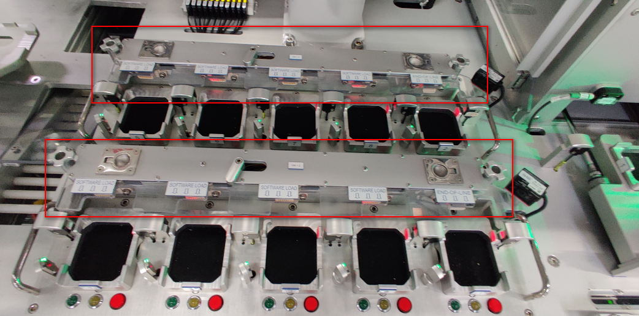

# Method of measurement

The acceptance criteria has been defined and listed for the Radar 5 SEL and the Fixture will be verified to meet the acceptance criteria.

# List of the ACCEPTANCE CRITERIA for SEL tester

See the attached file.

***List of the Acceptance Criteria For Radar 5 SEL tester.***



# Conclusion

The Radar 5 SEL tester is conformed to meet the acceptance criteria and production requirements.